**QuizMaster**

Overview:

* How to use QuizMaster app

Steps:

Locate and click on QuizMaster icon in application menu

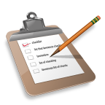

1. After clicking above QuizMaster icon you will see below screen:

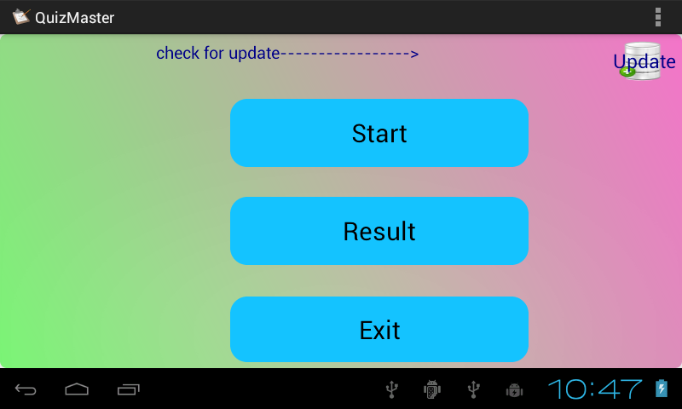

1. This is home screen of QuizMaster app. This screen provide three option as you seen.If you are first time using this app click on start button to start quiz.
2. Once you click on Start button new screen appears like this:

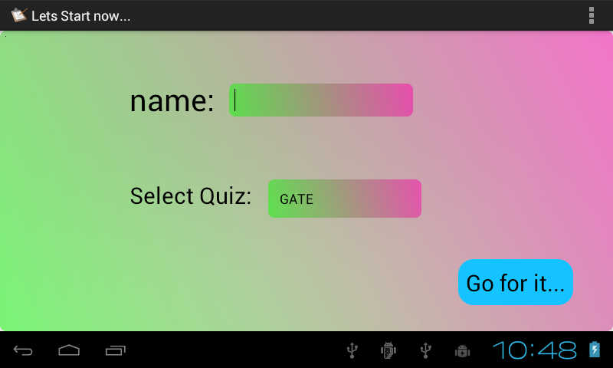

On this screen just type your name and select quiz from dropdown box as shown below.

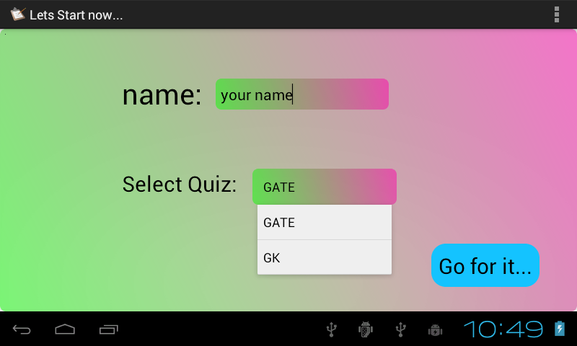 If you forgot to provide name in textbox and click on “Go for it…” button, new screen appear with wider textbox so that you just remember to enter your name in textbox. This look like this

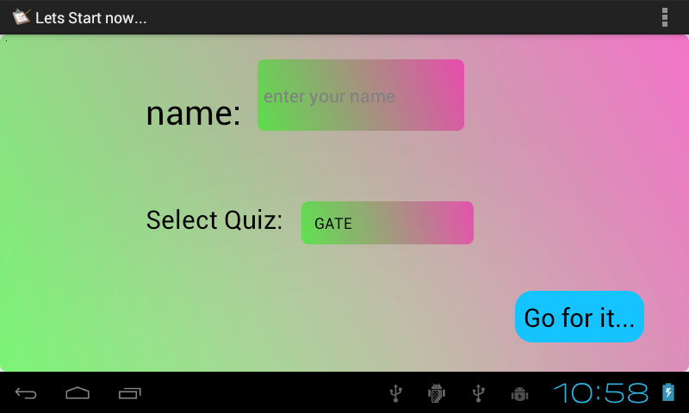

1. Once you type your name and select Quiz name and click on “Go for it..” button, screen with QUESTION and its 4 option appear as follow.

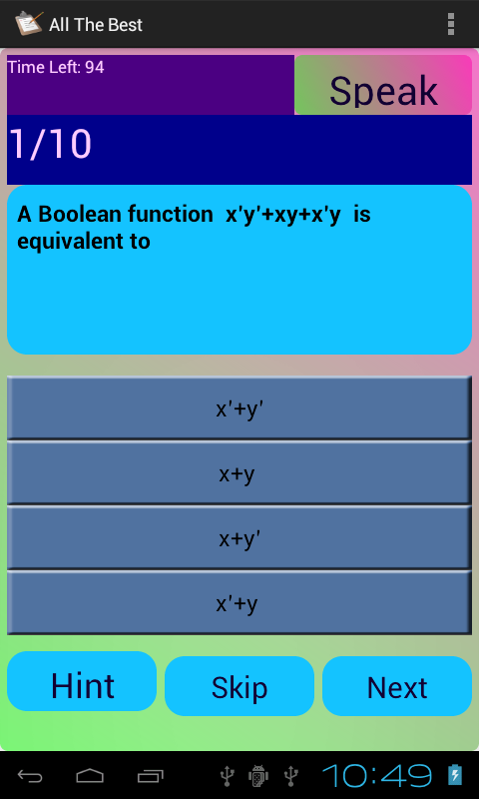

On this screen you just seen Question number ,Question, 4 option, Speak button ,Hint button ,skip button ,Next button ,Time Left(in seconds).

You can do one of the following things with this screen:

1. Press “Speak” button: once you press “Speak” button, app will speak QUESTION and its for 4 option. You may listen number of times question as many time as you press “Speak” button.
2. Press “Hint” button: “Hint” button just show true answer for question display at that time. But once you press “Hint” button you can not give its answer rather you have to just click on skip button to skip to next question.

Below screen is shown after pressing “Hint” button.

All the other button except “Skip” button is just disable.

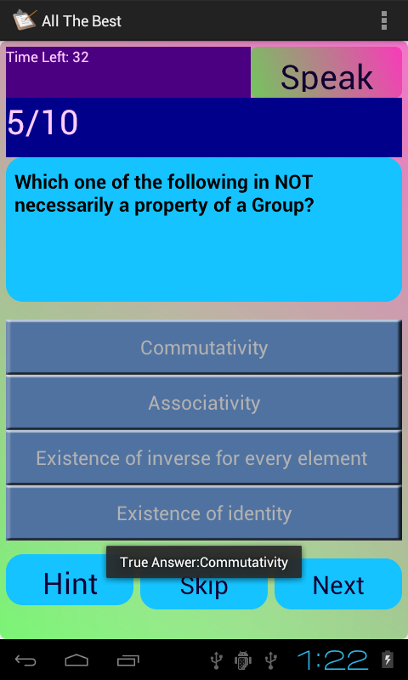

1. To give answer to question just click on one of the 4 option(Be careful, once you press any option its final choice and no alteration is permitted) and if you press any option then its compulsory to press next button to give answer to current question and to view next question. After clicking any one of the 4 option, “Hint”,”Skip” button is just disable for a present question.
2. Press “Skip” button: You can click on “Skip” button to skip current question if you dont know its answer or dont want to answer that question. If you skip all 10 question then result screen lool like this:

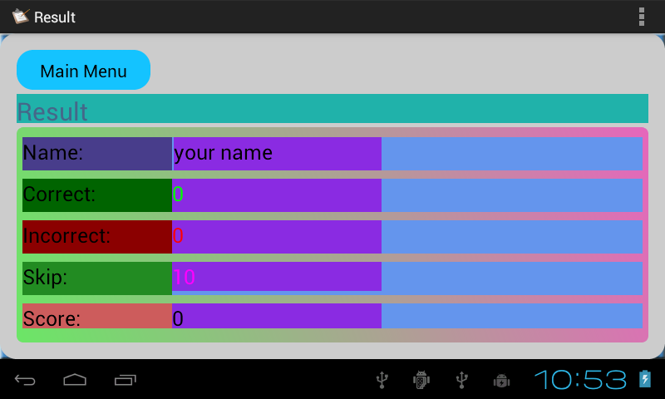

1. To give answer just presses its option and press “Next” button.

If you successfully completing all 10 question, “Next” button just change its name to “Show” button. Once you click “Show” button then below screen appears.

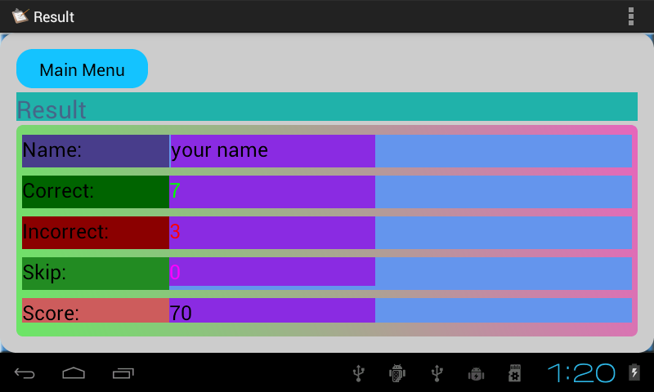

1. If you take to much time in giving answer (more than 100 seconds for 10 question) below dialog box appears. 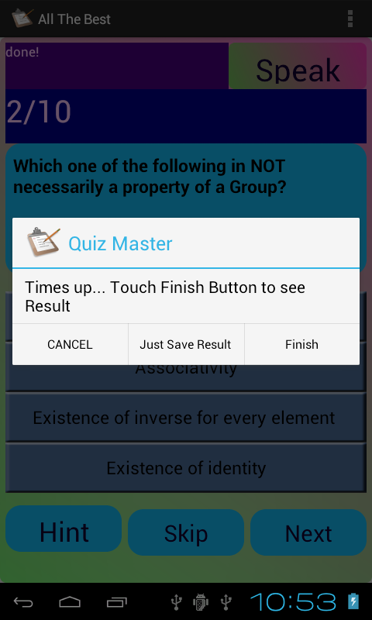

You can do three thing with this dialog.

1. Press “Cancel” button: if you don’t want to store result of current quiz. After pressing “Cancel” button, Home screen is appears.
2. Press “Just save Result”: if you want to save result but don’t want to show its result(with its summary).
3. Press “Finish” button to show result with summary.
4. After clicking “Main Menu” button, Home screen display.

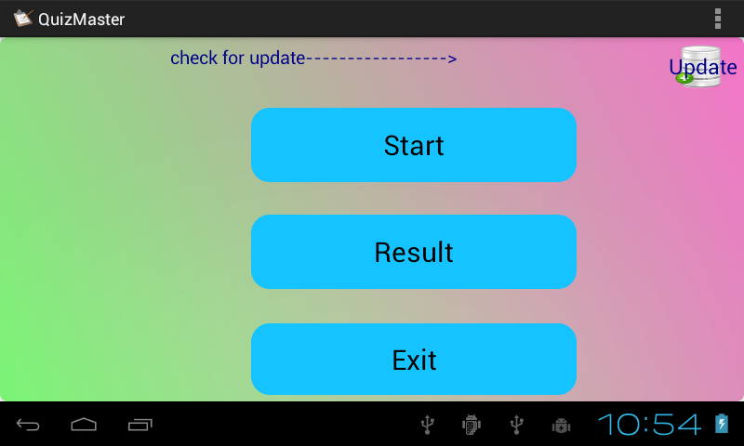

You can do 4 things:

1. Press “Start” button to start new Quiz.
2. Press “Update” button to check for newer version of app.

If no internet connectivity is available screen display this:

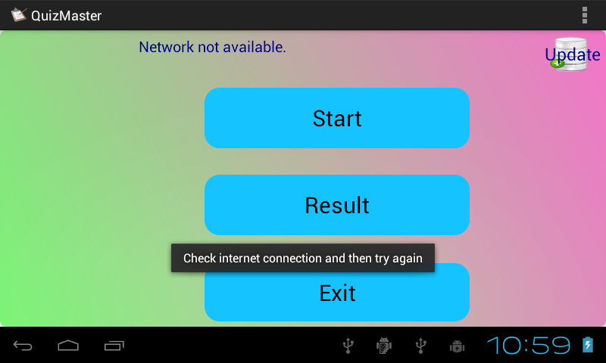

1. Press “Result” button to see performance of quiz you give.

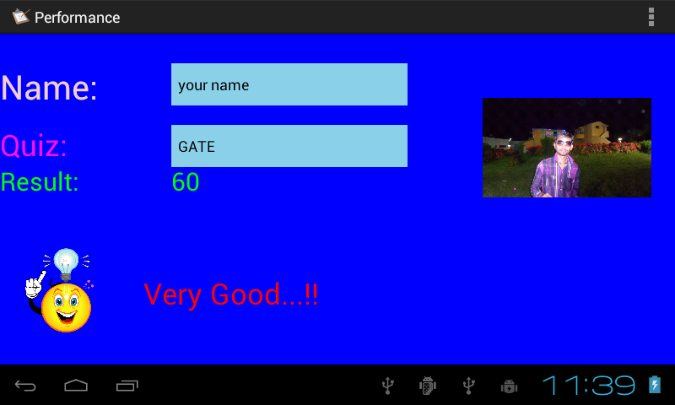

To show performance of Quiz you just give just select name from dropdown box like this::

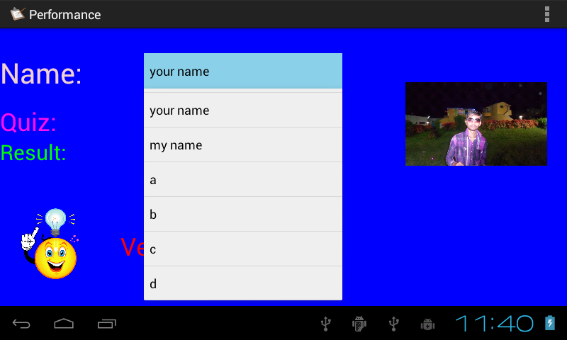

Then just select quiz name from another dropdown box as shown below:

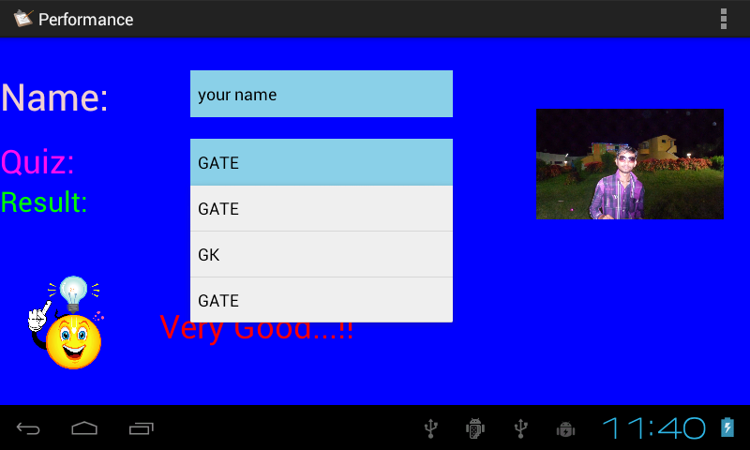

Most recently given quiz is display at the bottom of dropdown box.

Press “Back” button to go back to Home screen.

1. Press “Exit” button to exit the QuizMaster app.

On pressing exit button exit confirmation dialog is appears.

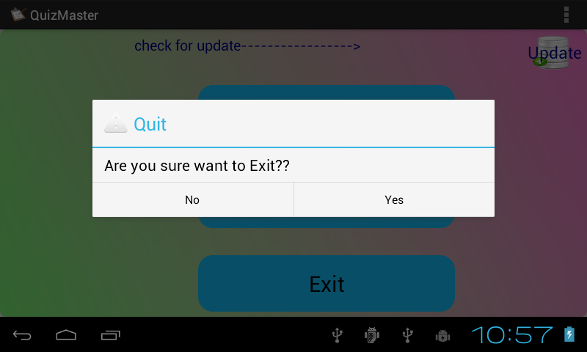

Press yes if you want to exit QuizMaster or “no” otherwise.